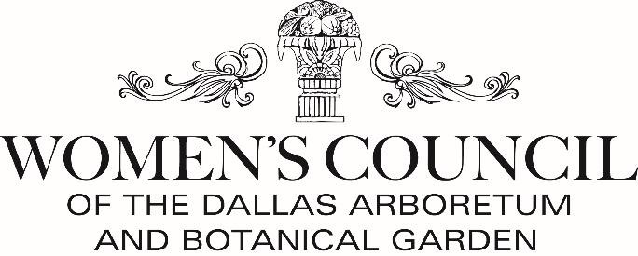
2023-2024 Membership Form
Joining online is easier and encouraged! Simply go to wcdabg.org or text Member2023 to 41444.

Membership Status: _____ New _____ Renewing _____ Returning (after a year+)
If new, referred by: __________________________________________________________________________

First and Last Name: ________________________________________________________________________
Address ___________________________________________________________________________________
City __________________________ State ______________ Zip _______________________
Email: _____________________________ Cell Phone: _________________ Home: ____________________
Preferred Social Address: ____________________________________________________________________
(Mr. and Mrs., Dr. and Mrs. , Ms., The Doctors)

Join the Lisianthus Society
*Donations of $500 or more include an annual membership in the Lisianthus Society which includes special recognition in the annual yearbook and an exclusive Spring event for Lisianthus Society members.

- $60 Member
- $100 Sustainer
- $250 Contributor
- $500 Patron*
- $1000 Benefactor*
Optional:
- $10 for mailed newsletters**

TOTAL ______________________________
**To receive mailed newsletters during the year you may subscribe to this additional service. Newsletters will be emailed at no charge and posted on our website.
To join, please make your check payable to “WCDABG” and mail this completed form with payment to:

Mary Ellen Winborn
4209 Hanover Street
Dallas, TX 75225

Yes! I’m interested in growing A Woman’s Garden. I’d like to help with

___ A Writer’s Garden, November 7, 2023 ______ Mad Hatter’s Tea, April 18, 2024

___ Membership Meetings ___ Volunteer Days in A Woman’s Garden ___ Educational Trips

THANK YOU for your support of the Women’s Council of the Dallas Arboretum and Botanical Garden.

